11.41: a) Take torques about the rear wheel, so that 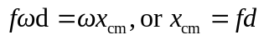.
b) 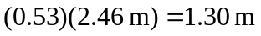 to three figures.

